KJAM Project Management System

Software Architecture Document

Version <2.0>

KJAM
Alejandra Yepez
John Teasler
Micah Bauer

Revision History
Date | Version | Description | Author
3/03/09 | 1.0 | 1.1, 1.4, 2.1.1, 2.2.2, 2.5, 2.6, 3 | Micah
3/03/09 | 1.0 | 1.3, 1.5, 2.1.2, 2.2.2, 2.3 | Alejandra
3/03/09 | 1.0 | 1.2, 2.2, 2.2.2 | John

Table of Contents
1. Introduction 4
1.1 Purpose 4
1.2 Scope 4
1.3 Definitions, Acronyms, and Abbreviations 4
1.4 References 4
1.5 Overview 4
2. Architectural Representation 5
2.1 Static Structural Model 5
2.1.1 Architectural Model 5
2.1.2 Subsystem Models 5
2.1.3 Hardware Configuration 7
2.2 Dynamic Process Model 7
2.2.1 Overview 7
2.2.2 Significant Dynamic Models 8
2.3 Interface model 15
2.4 Relationship model 17
2.5 Distribution Model 18
2.6 Implementation View 18
3. Quality 1
8

Software Architecture Document

Introduction

Purpose
The Software Design Description is intended to be used by the developers of KJAM. It is intended to show an overview of the architecture of the system. Diagrams and descriptions are provided for this purpose.

Scope
The document is for the overall software architecture of the KJAM software. This document describes the interaction between classes and gives an over all functions and variables for classes.

Definitions, Acronyms, and Abbreviations

This document employs several abbreviations and acronyms to refer concisely to an item, after it has been introduced. The following list is aimed to help the reader in recalling the extended meaning of each short expression:

GUI | Graphical User Interface
DBMS | Data Base Management System
I/O | Input/output
N/A | Not Applicable
MODULE | class
OO | Object Oriented
PK | Primary Key
SDD | Software Design Description
Subsystem | Module that contains various classes

References
N/A

Overview
The Software Design Description presents a graphical representation about the architecture model used in order to model the KAJM Project Management System. This document contains the architectural representation of the system that provides a definition of the major components of the system and their communication. In addition, the document contains the static structural model of the system and the subsystem that includes class and collaboration diagrams in order to model the system and understand how the system will be built.

Architectural Representation

Static Structural Model

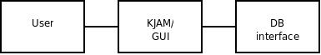
The user interacts with the KJAM GUI, which, in turn, interacts with the interface to the database.

Architectural Model

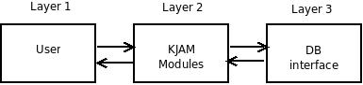
The user interacts with the various KJAM modules, which, in turn interacts with the interface to the database.

Subsystem Models
The model has a Login GUI class in order to provide the login functionality in the system. The user enters the information requested by this class, and it validates the information in the DBMS in order to provide the adecuate access. Then, the MENU GUI gives access to the other module classes that interact with the DBMS. This information can be seen in Figure 2.1.2.1. In addition, the DBMS contains the classes related with the internal operation of the syste, (Figure 2.1.2.2).

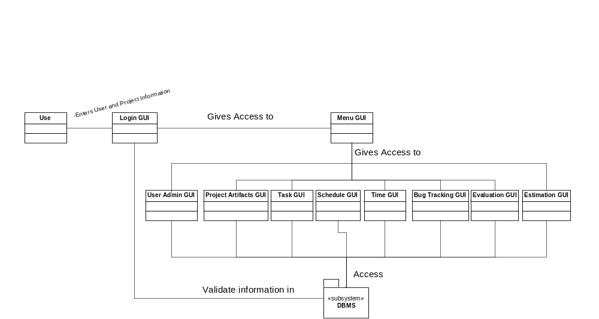 Figure 2.1.2.1: Class Diagram of the KJAM System

Figure 2.1.2.2 shows the association between the different tables in the DBMS. The class diagrams shows some object oriented design patterns such as the Time-Association pattern, and the Item-Description Pattern. The Time-Association pattern is applied to the user and project using the table User Project Manager as the associated even between them. The same pattern has been applied to User Time Task manager. The Item-Description Pattern was applied to the Project table and the Artifacts associated to them. The same was applied for Bugs and Users.
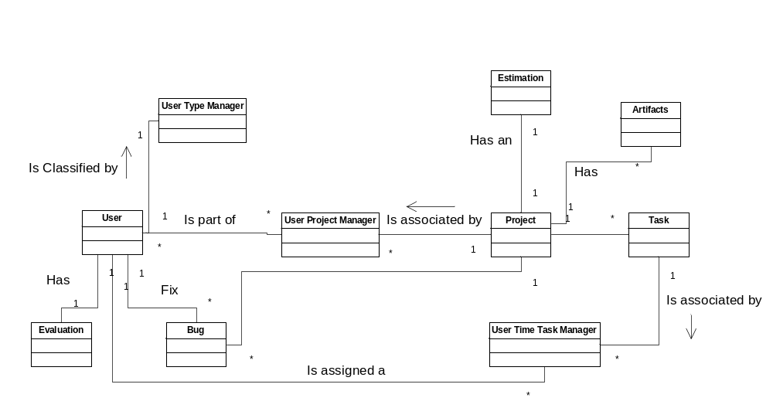
Figure 2.1.2.2: DBMS Class Diagram

Hardware Configuration
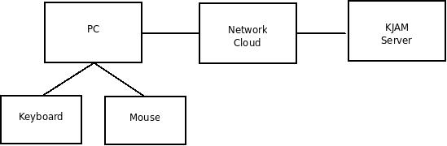
A keyboard and mouse are connected to a client PC, which is connected to a network, which, in turn, is connected to the KJAM server.

Dynamic Process Model
The system has eight significant classes: Project Artifacts, Time, Evaluations, Bug Tracking, Schedule, Admin, and Estimations. Time will collaborate with the Tasks to get time for each tasks that is founded

Overview
The significant use cases driving the need for these system services are:
- Log in
- Download a project artifact
- Upload a project artifact
- View schedule of activities
- Report a bug or feature request
- View an individual bug or feature request
- Add comments to a bug or feature request
- Close a bug or feature request
- View all bugs and feature requests
- View estimation of a project
- Create a task
- View a task
- Modify a task
- Delete a task
- Mark a task as complete
- View team times
- View evaluations
- Evaluate a team member
- Create a project
- Modify a project
- Delete a project
- Create a user
- Modify a user
- Delete a user

Significant Dynamic Models

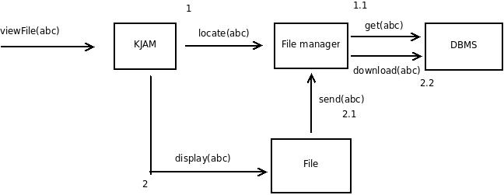
Figure 2.2.2.1 Collaboration Diagram for Downloading a Project Artifact

The user requests to view file abc.
KJAM sends message locate to File manager ← true if located.
File manager sends message get to DBMS.
If (file found) KJAM sends message display to File to display abc.
File sends message send to File manager.
File manager sends message download to DBMS.
DBMS sends file to user.
If (file not found) do nothing.

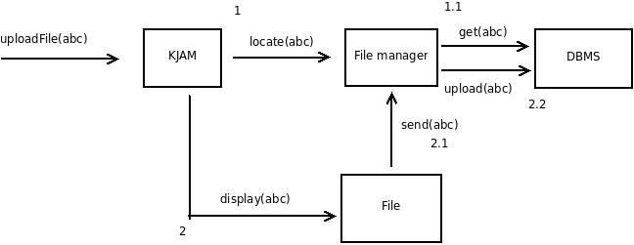
Figure 2.2.2.2 Collaboration Diagram for Uploading a Project Artifact

The user requests to upload file abc.
KJAM sends message locate to File manager ← true if located.
File manager sends message get to DBMS.
If (file found) KJAM sends message display to File to display abc.
File sends message send to File manager.
File manager sends message upload to DBMS.
DBMS gets file from user.
File will replace old file.
If (file not found) file will not replace an old file.

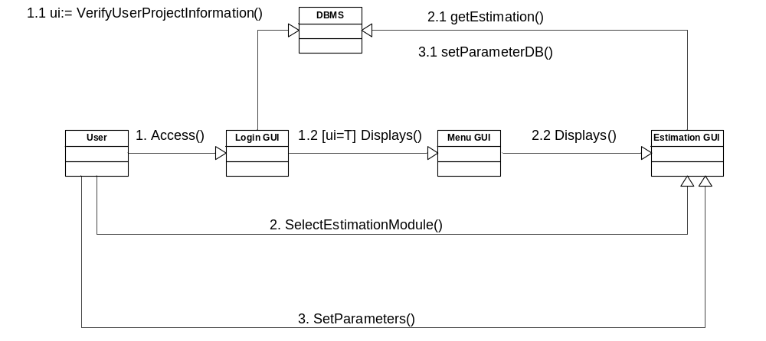
Figure 2.2.2.3 Collaboration Diagram for the Estimation System

The user requests access Login GUI
KJAM Login GUI sends message display to Menu GUI ← true if it’s display.
Menu GUI sends message display to Estimation GUI.
If (Menu GUI displays) user selects estimation module to show the Estimation GUI.
User sets parameters for the estimation
If (Menu GUI not display) Error in Login GUI

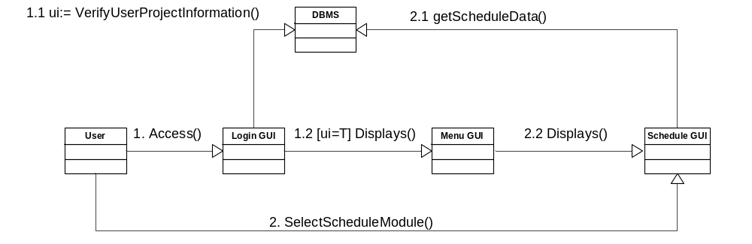
Figure 2.2.2.4 Collaboration Diagram for the Schedule System

The user requests access Login GUI
KJAM Login GUI sends message display to Menu GUI ← true if it’s display.
Menu GUI sends message display to Schedule GUI.
If (Menu GUI displays) user selects schedule module to show the Schedule GUI.
If (Menu GUI not display) Error in Login GUI

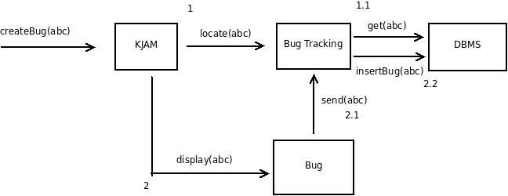
Figure 2.2.2.5 Collaboration Diagram for Creating a Bug

The user requests to create bug abc.
KJAM sends message locate to Bug Tracking ← true if located.
Bug Tracking sends message get to DBMS.
If (bug found) KJAM sends message display to File to display abc.
Bug sends message send to Bug Tracking.
Bug Tracking sends message insertBug to DBMS.
DBMS adds bug.
If (bug not found) do nothing.

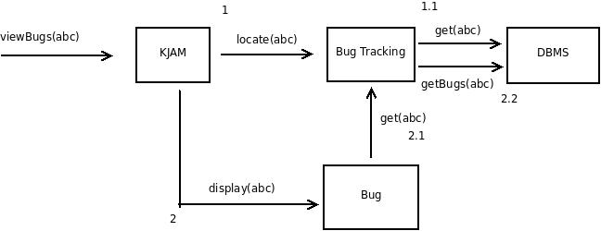
Figure 2.2.2.6 Collaboration Diagram for Viewing a Bug

The user requests to view bug abc.
KJAM sends message locate to Bug Tracking ← true if located.
Bug Tracking sends message get to DBMS.
If (bug found) KJAM sends message display to Bug to display abc.
Bug sends message send to Bug Tracking
Bug Tracking sends message getBugs to DBMS.
DBMS sends bug to user.
If (bug not found) do nothing.

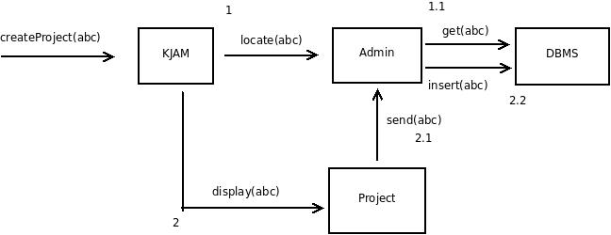
Figure 2.2.2.7 Collaboration Diagram for Creating a Project

The user requests to create project abc.
KJAM sends message locate to Admin ← true if located.
Admin sends message get to DBMS.
If (project not found) KJAM sends message display to Project to display abc.
Project sends message send to Admin.
Admin sends message insert to DBMS.
If (project found) do nothing.

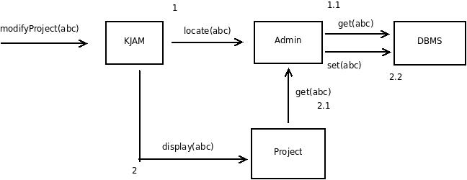
Figure 2.2.2.8 Collaboration Diagram for Modifying a Project

The user requests to modify project abc.
KJAM sends message locate to Admin ← true if located.
Admin sends message get to DBMS.
If (project found) KJAM sends message display to Project to display abc.
Project sends message get to Admin.
Admin sends message set to DBMS.
If (project not found) do nothing.

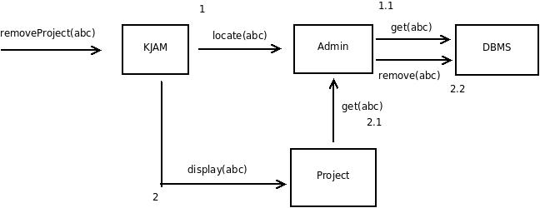
Figure 2.2.2.9 Collaboration Diagram for Deleting a Project

The user requests to remove project abc.
KJAM sends message locate to Admin ← true if located.
Admin sends message get to DBMS.
If (project not found) KJAM sends message display to Project to display abc.
Project sends message get to Admin.
Admin sends message remove to DBMS.
If (project found) do nothing.

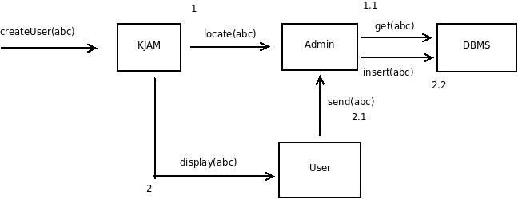
Figure 2.2.2.10 Collaboration Diagram for Creating a User

The user requests to create user abc.
KJAM sends message locate to Admin ← true if located.
Admin sends message get to DBMS.
If (user not found) KJAM sends message display to User to display abc.
User sends message send to Admin.
Admin sends message insert to DBMS.
If (user found) do nothing.

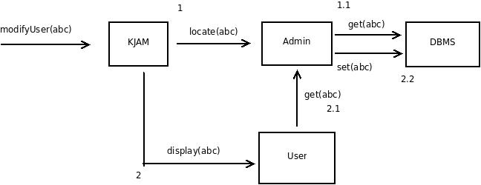
Figure 2.2.2.11 Collaboration Diagram for Modifying a User

The user requests to modify user abc.
KJAM sends message locate to Admin ← true if located.
Admin sends message get to DBMS.
If (user not found) KJAM sends message display to User to display abc.
User sends message get to Admin.
Admin sends message set to DBMS.
If (user found) do nothing.
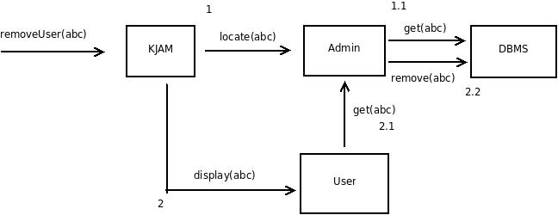
Figure 2.2.2.12 Collaboration Diagram for Deleting a User

The user requests to remove user abc.
KJAM sends message locate to Admin ← true if located.
Admin sends message get to DBMS.
If (user not found) KJAM sends message display to User to display abc.
User sends message get to Admin.
Admin sends message remove to DBMS.
If (user found) do nothing.

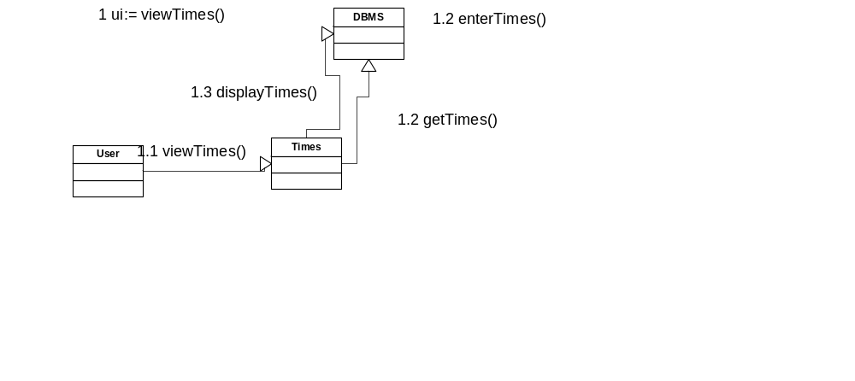
Figure 2.2.2.13 Viewing Times
User asks to View Times
Times gets the Time of each Task
Displays Times of each Task

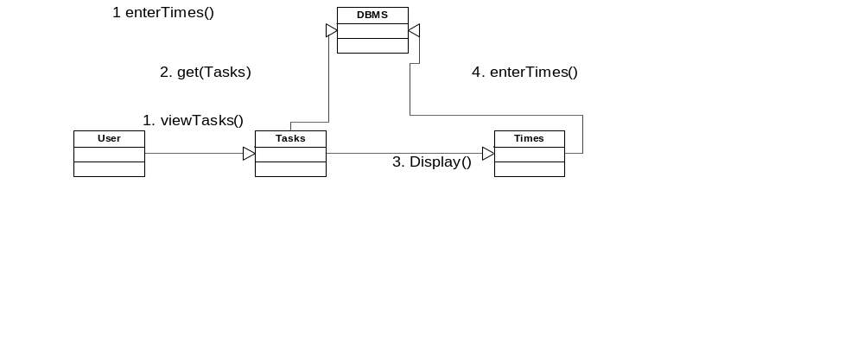
Figure 2.2.2.14 Enter Times
The user goes to submit tasks
Tasks gets the tasks for that user.
User enterTimes for completed tasks
Times takes the times and upload them to the Database

Evaluations
User wants to do evaluation
User clicks on Evaluate
System allows user to download file
User download files and enters the evaluations on the form
User uploads the Evaluation form
System puts the Evaluation on the Database

User wants to view evaluation
User clicks on View Evaluation
System ask the database for the evaluation of current user
System displays the evaluation for the user

Interface model
The system has 3 different classes of users: Administrator, Project Manager, and Team Member. For every user we can see what is the communication with the different module of the system.
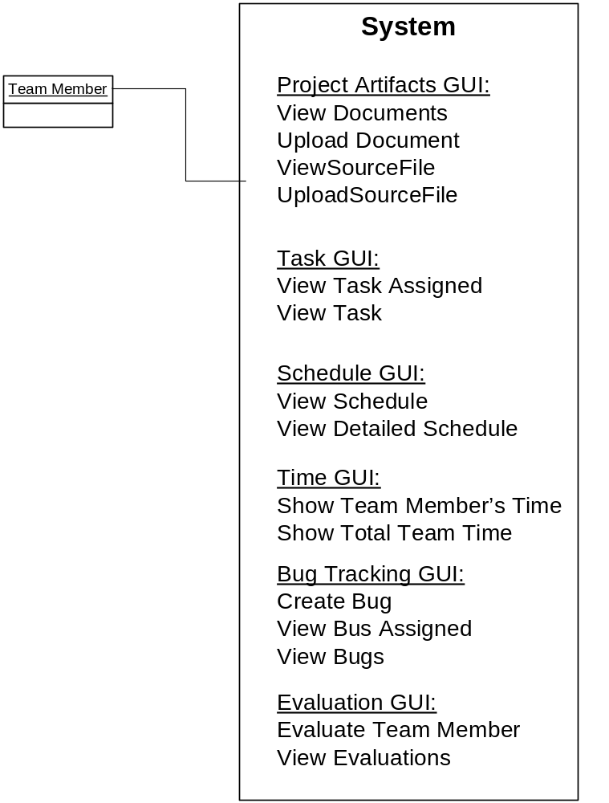
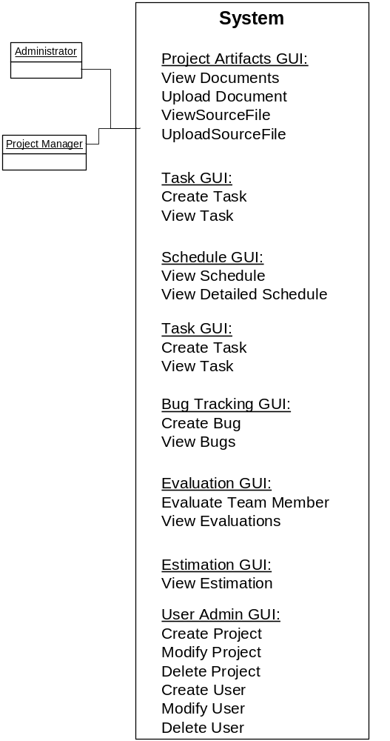

Relationship model
N/A

Distribution Model

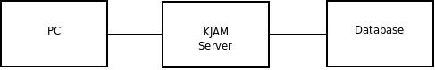
The client program will run on a PC. The PC will be connected to the KJAM server through a network. The KJAM servr will either host the database or have network access to it.

Implementation View

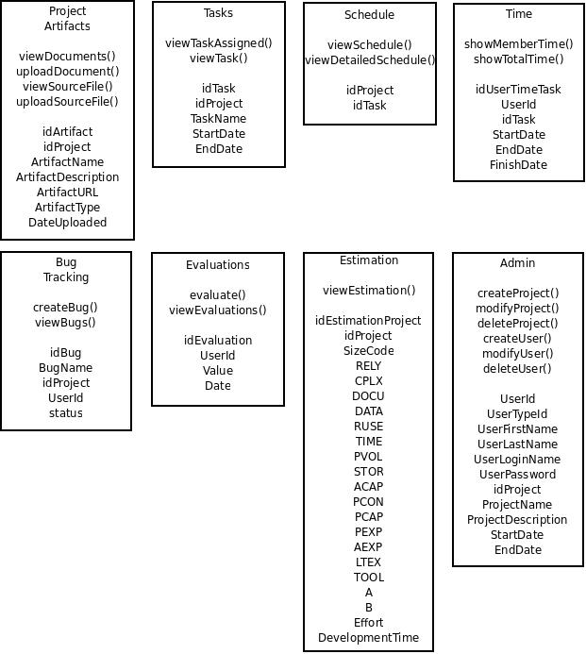

Here is the Subsystem conforms by the database of the system. The next figure represents the design class diagram for the system with every table and its corresponding attributes.
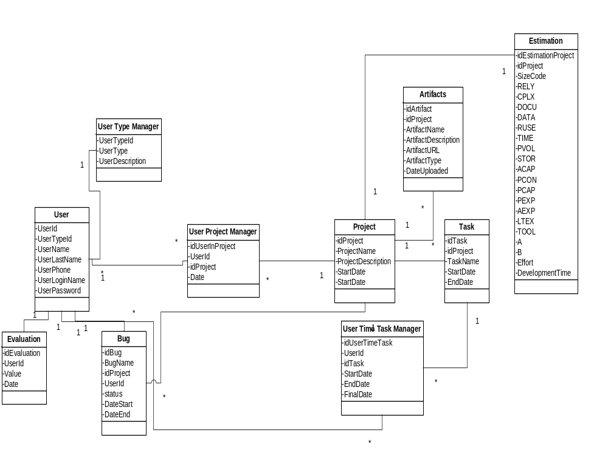

Quality

The modular nature of the system lends itself to the nature of the system as extensible. The various classes of users and control of the Project Manager class are beneficial to the system's security and privacy.

